Key Information | Name: Robert Box  Date of Birth: 3rd Feb 1919  Academic career: Creighton 1930-33  War Service: Private; 3600902,  Battalion: 8th Bn., Parachute Regiment, A.A.C.  Date of Death: 25/08/1944 25  Other:  Buried/Commemorated: VATTEVILLE-LA-RUE CHURCHYARD  France
Family Background | Robert was the fifth of eight children born to Thomas Box and his wife Elizabeth nee Hetherington. Robert’s father Thomas had been born in Carlisle and worked on the railways for his whole working life. Robert’s paternal grandfather Robert had been a gas stoker in Carlisle and his maternal grandfather John Hetherington had worked in a dyehouse in Carlisle.
School Record | Bishop Godwin PS. Creighton School 1930-33.
War Service | On 6 June 1944, the 8th Parachute Battalion landed in Normandy on their own drop zone 'K' between Cuverville and Touffréville 3 miles (4.8 km) to the south of the main force at Ranville.The battalion's objectives were to destroy two bridges crossing the River Dives near Bures and a third at Troarn. The parachute drop was widely scattered, with fourteen of the Battalion's thirty-seven Dakota aircraft, releasing their parachutists some distance away, in the operational area of 5th Parachute Brigade When the commanding officer Lieutenant-Colonel Pearson arrived at the battalion rendezvous point (RVP) at 01:20, he found only thirty paratroopers and a small group of engineers with a jeep and trailer who were supposed to demolish the bridges. By 03:30 a further 140 men of the battalion, but no more engineers had arrived at the RVP Pearson decided to send a small force to demolish the bridges at Bures and lead the rest of the battalion to a crossroad north of Troarn where it would await more reinforcements before it attacked Troarn itself. However, the small force sent to Bures discovered that the two bridges had already been demolished by a group of engineers who had reached the bridges a few hours earlier, and so rejoined the battalion at the crossroads, which by now numbered 150 men. A reconnaissance party was sent into Troarn to ascertain the status of the bridge there, alongside a party of engineers, which came under fire from a house near the bridge. After a brief fire-fight the paratroopers captured a number of Germans from the 21st Panzer Division and then made their way to the bridge, which they discovered had been demolished already. Once the engineers had widened the length of bridge demolished using their explosives, the party retreated back to the battalion at the crossroad Having achieved its objective, the battalion then moved north and took up positions near Le Mesnil to widen the airborne bridgehead formed by the division. By midnight the battalion was in the Bavent woods. The southernmost point in a 4 miles (6.4 km) defensive line formed by the 3rd Parachute Brigade, stretching northwards from the woods, to Les Mesnil and then Le Plein.  The 8th Battalion's objective was to hold the woods and disrupt German movements in the area. Isolated from the rest of the division, they were assisted in their defence by the dense woods, which broke up infantry assaults and made armoured vehicle attacks impossible. They did however suffer under artillery bombardments, until their trenches had adequate over-head cover. Adopting a policy of mine laying, setting ambushes, raiding and patrolling, at times the battalion's patrols reached as far as Bures and Troarn.The battalion remained in the woods until 16 June, when the 3rd Parachute Brigade went into reserve. When they returned to the front, they continued patrolling and harassing the Germans for the next six weeks. Until 17 August when the 6th Airborne Division, crossed the River Dives. The 8th Battalion were involved in heavy fighting at Goustranville, which they captured by nightfall. By 21 August the battalion, had reached Annebault. Supported by a left flanking attack by the 9th Parachute Battalion, the 8th put in a frontal assault. The village was well defended and both battalions fought all day to liberate the village The 8th Battalions next major engagement was on 25 August at Beuzeville, attacked by the 3rd Parachute and the 4th Special Service Brigade. Supported by the Cromwell tanks of the 6th Airborne Division Reconnaissance Regiment the battalion gradually overcome the German strong points and captured the town  Tragically Robert was killed accidentally by British fire, after being wounded and captured by a German patrol.
Battalion | 8th Battalion the Parachute Regiment
Other | In 1939 Robert was working in a sawmill as a labourer. He had married Barbara M Lithgow in late 1937 when he was eighteen years old. Their son John was born in 1938 and their daughter Maureen in 1941.  Address when at school, 3, Ridley Place, Currock.  Barbara remarried in early 1946 William M. Wright.
Contacts
Sources | 1939 register  Census returns  Ancestry Trees  Wikipedia  The Creighton Register
To Do

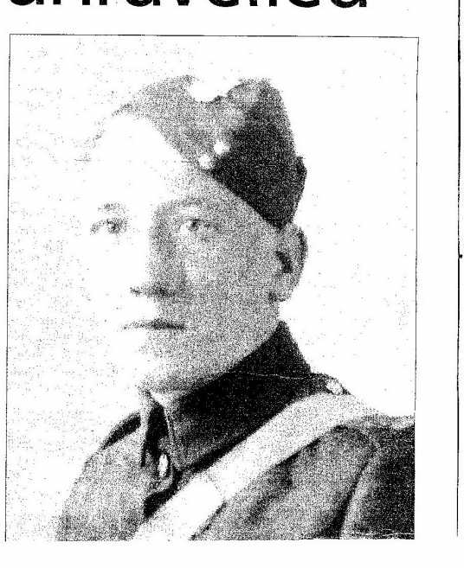Picture taken from Ancestry trees...permission being sought.

