Acceptable Boys School Shoes Trinity School

Black lace up shoes or velcro fastenings which provide support and protection from all weather.

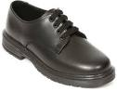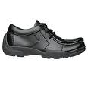
Lace up Lace up

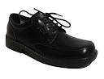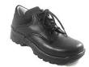
Lace up Lace up

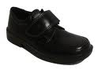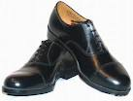
Velco fastening Lace up traditional shoe

Acceptable Girls School Shoes
Trinity School

Black shoes which provide support and protection from all weather.

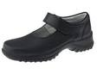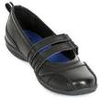
Buckle Shoe – sensible heel Buckle Shoe – flat shoe

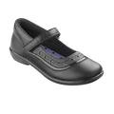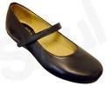
Buckle Shoe – traditional shoe Flat shoe with support strap

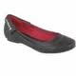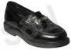
Sturdy fitted slip on Loafer

Shoes which are not accepted as school Trinity School shoes and should not be worn as part of everyday uniform

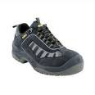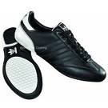
Walking Boot Trainers
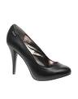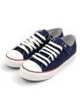
Heels of any type more than 2 inches Converse or similar shoe
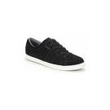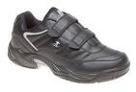
Sneaker Trainer (velcro)
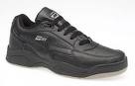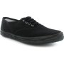
Trainer (laced) Pumps of any sort

