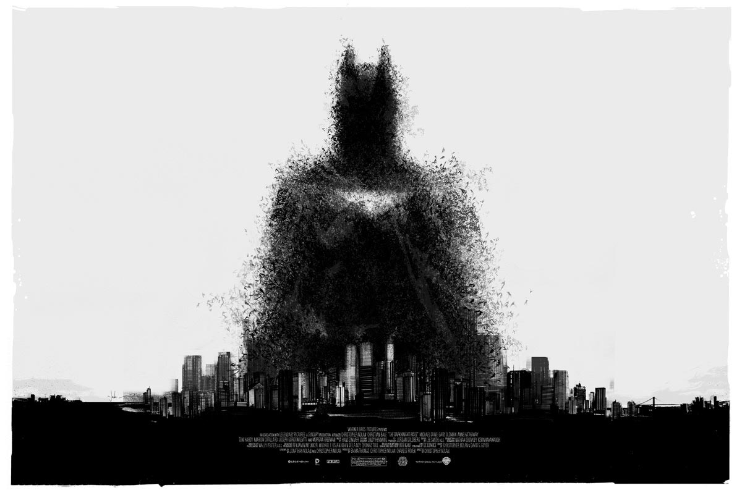
JUST A MAN IN A CAPE?
Last week we looked at what community is to us. This week we are going to look at how we make a difference in our communities. We all have an impact on the world around us; sometimes for the better and sometimes for the worst. As a group how we behave decides what our communities are like. If as a form we treat each other with respect and kindness then school will be a pleasant place to be but if we bully and treat each other with disrespect then school will be an unhappy place to be. Similarly the things we do will either have a positive or negative impact on the wider world around us; if we litter the Carlisle will be a dirty place to live, if we don’t recycle then the world we live in will become a mess, if we give money to charity then the lives can be saved. If we saw all our interactions with others as either having a positive or negative impact on our communities then how would we change how we behave?

