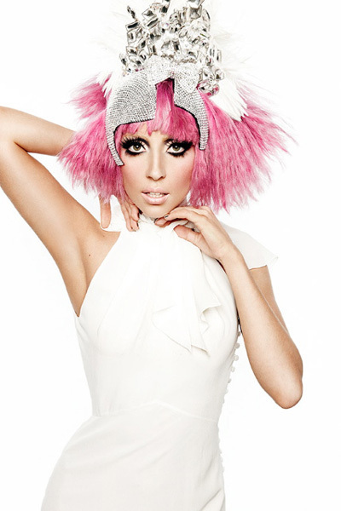
"Born This Way" – Lady Gaga
It doesn't matter if you love him, or capital H-I-M
Just put your paws up
'cause you were born this way, baby
My mama told me when I was young
We are all born superstars
She rolled my hair and put my lipstick on
In the glass of her boudoir
"There's nothing wrong with loving who you are"
She said, "'Cause he made you perfect, babe"
"So hold your head up girl and you'll go far,
Listen to me when I say"
I'm beautiful in my way
'Cause God makes no mistakes
I'm on the right track, baby I was born this way
Don't hide yourself in regret
Just love yourself and you're set
I'm on the right track, baby
I was born this way
Oh there ain't no other way
Baby I was born this way
I'm on the right track, baby
I was born this way
Give yourself prudence
And love your friends
Subway kid, rejoice your truth
In the religion of the insecure
I must be myself, respect my youth
Don't be a drag, just be a queen
Whether you're broke or evergreen
You're black, white, beige, chola descent
You're Lebanese, you're orient
Whether life's disabilities
Left you outcast, bullied, or teased
Rejoice and love yourself today
'cause baby you were born this way
No matter gay, straight, or bi,
Lesbian, transgendered life,
I'm on the right track baby, I was born to survive.
No matter black, white or beige, chola or orient made,
I'm on the right track baby, I was born to be brave.
I was born this way hey! (x2)
I'm on the right track baby
I was born this way hey! (x3)
I'm on the right track baby
I was born this way hey!
Same DNA, but born this way.
Same DNA, but born this way.
“Cause God makes no mistakes... he made you perfect”

Bullying is wrong... together we can stop it...tell someone today

